Zainab’s Testimonial: 23/4/2019 DMU Graduate

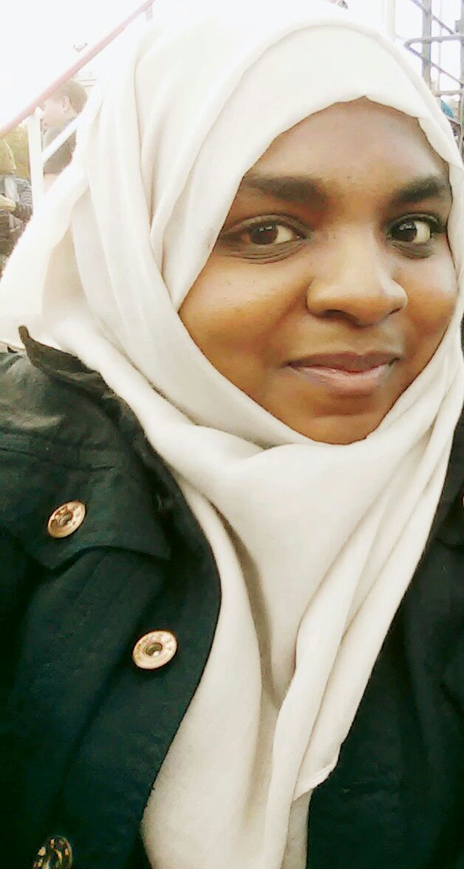

Hello my name is Zainab Abdul and I am a DMU graduate student that applied through the DMU graduate champions scheme where I was offered a job as a bid writer and fundraiser here at Diabetes self-help group. I got the chance to able to create posters and leaflets, which developed my creative thinking in a way where I got to try out different styles and ideas by using publisher and adobe illustrator which I knew little about but now I feel more confident with the software and I hope to do more of this in future. It has also taught me how to manage time and be more organised which was especially helpful because I can apply this in a any working environment. I felt like some of the skills in which I was gaining out of this, reflected back on my Health Studies course because sometimes it meant doing a bit of research and writing up newsletters. It has also been an eye opener because being able to be a part of a group who are willing to help those struggling with diabetes and other health related problems, makes me feel very lucky. My overall experience is that, it has also helped me realise my own potential and what I want to go into in future. and I got to experience new skills, be flexible in terms of working and to always stay positive. thank you for listening and thank you Sonal.

